Retail Sales Dashboard: Power BI Project Report

1. Introduction
Retail businesses generate large volumes of transactional data every day, but the data only creates value when it is turned into clear, decision-ready information. This project builds an interactive Retail Sales Dashboard in Microsoft Power BI for an electronics retailer operating across India through physical stores and an online store.
The report is built on a star-schema data model with one fact table (Fact Sales, 15,000 transaction lines) and eight dimension tables covering products, stores, cities, states, customers, orders, salespeople and dates. The dashboard has two pages:
- RETAIL SALES DASHBOARD
- STORE TYPE TOOLTIP
All monetary values are assumed to be in Indian Rupees (₹), based on the Indian cities and states in the data.

2. Objectives
- To design a clean star-schema data model from nine CSV source files.
- To clean and transform the raw data using Power Query so it is ready for analysis.
- To create reusable DAX measures for revenue, cost, profit, quantity, orders and average order value.
- To present headline performance through KPI cards.
- To analyse sales and profit by product category, geography, store, customer segment and time period.
- To give users interactive slicers and tooltips so they can explore the data themselves.
- To identify the key findings that can support business decisions.

3. Dataset Description
The data comes from the D6 – Electronics Retail Sales Dataset, supplied as nine CSV files and loaded into Power BI. The sales data covers January 2024 to January 2026. Revenue is almost entirely from 2024 and 2025, and 2026 holds only a few days of January.
Table | Type | Rows | Description
Fact Sales | Fact | 15,000 | One row per sale line: quantity, unit price, discount, tax, total amount, cost, profit, profit margin and return details
Dim Product | Dimension | 190 | Product name, category, subcategory, brand, supplier, unit cost and price, stock levels
Dim Store | Dimension | 13 | Store name, type (Flagship, Urban, Mall, Suburban, Online), manager, opening date, size, employees
Dim City | Dimension | 10 | City name and state link (includes an "Online" pseudo-city)
Dim State | Dimension | 9 | State name and code (includes "Online / National")
Dim Customer | Dimension | 1,000 | Customer details and segment (Regular, Occasional, Premium, Value)
Dim Order | Dimension | 15,000 | Order number, status, channel, shipping, payment and delivery dates
Dim Salesperson | Dimension | 80 | Employee code, department, job title, commission rate
Dim Date | Dimension | 731 | Calendar attributes: day, month, quarter, year, fiscal year, weekend and holiday flags
Key facts about the fact table
- 15,000 sales lines, each with a unique Sales_id and a unique Order_id (one product line per order).
- 112,353 units sold in total, an average of about 7.5 units per order.
- Seven product categories: Mobile Phones, Laptops, Televisions, Home Appliances, Audio, Wearables and Accessories.
- 292 lines (about 1.95%) are flagged as returned.

Data model relationships
From (many side) | To (one side) | Cardinality | Filter direction
Fact Sales[Product_id] | Dim Product[Product_id] | Many-to-one | Single
Fact Sales[Customer_id] | Dim Customer[Customer_id] | Many-to-one | Single
Fact Sales[Store_id] | Dim Store[Store_id] | Many-to-one | Single
Fact Sales[Salesperson_id] | Dim Salesperson[Salesperson_id] | Many-to-one | Single
Fact Sales[Date_id] | Dim Date[Date_id] | Many-to-one | Single
Fact Sales[Order_id] | Dim Order[Order_id] | One-to-one | Both
Dim Store[City_id] | Dim City[City_id] | Many-to-one | Single
Dim City[State_id] | Dim State[State_id] | Many-to-one | Single
The product, customer, store, salesperson and date dimensions connect directly to the fact table (a star schema). The Store → City → State chain adds a small snowflake branch for geography.

4. Data Preparation
All preparation was done in Power Query. Each table was loaded from its CSV file and then transformed with a similar sequence of steps.

Steps applied
- Loaded CSV files using Csv.Document with the correct delimiter, column count and encoding (Windows-1252 for most tables, UTF-8 for Dim Product).
- Promoted headers so the first row of each file became the column names.
- Changed data types: IDs to whole numbers, amounts to decimal numbers, dates to date or datetime, and descriptive fields to text.
- Renamed columns to a consistent Title_case style (for example order_id became Order_id).
- Converted dates with the en-IN locale so Indian-format dates were read correctly (for example Created_at, Order_date, Delivery_date).
- Converted true/false flags: the source stored flags as t / f text. A custom column such as [Is_active] = "t" produced a true/false column (named Is_active_fixed, Is_weekend_fixed, Is_holiday_fixed, Is_returned_fixed, Has_online_ordeing_fixed), and the original text column was removed.
- Removed unnecessary columns, such as the original flag columns and Launch_date and Is_discontinued from Dim Product.
- Built the relationships between the fact and dimension tables on the ID columns.

Ii) Data quality observations
While reviewing the model, the following issues were found. They are worth cleaning in a future version.
Issue | Where | Effect on the report
Inconsistent text case: urban vs Urban | Dim Store[Store_type] (Noida DLF Mall) | Store type slicer shows "Urban" twice; Urban revenue is split into two groups (₹626.95M and ₹125.28M)
Leading space and different case: PREMIUM | Dim Customer[Customer_segment] (1 customer) | A separate tiny segment appears (₹4.68M revenue)
Leading space: website | Dim Order[Channel] (1 order) | Duplicate channel value
Column name typos | Rregistration_date, Has_online_ordeing_fixed | Cosmetic, but confusing
Blank salesperson | 300 fact rows have no Salesperson_id | Salesperson analysis would be incomplete
Blank return date | 14,708 rows (not returned) | Expected, since only returned lines have a date
"Online" stored as a city and state | Dim City, Dim State | Must be filtered out of city or state comparisons
27 automatic date/time tables | Model | Increases file size; can be switched off in Power BI options
Total amount includes tax | Fact Sales | Profit is calculated as Total_amount − Cost_amount, so profit is stated on a tax-inclusive basis

5. DAX Measures with Formulas
Eight measures were created in the Fact Sales table. All are simple, readable measures that respond automatically to every slicer and visual filter.
# | Measure | DAX formula | Purpose
1 | TOTAL QUANTITY | SUM('Fact Sales'[Quantity]) | Total units sold
2 | TOTAL REVENUE | SUM('Fact Sales'[Total_amount]) | Total sales value
3 | TOTAL COST | SUM('Fact Sales'[Cost_amount]) | Total cost of goods sold
4 | TOTAL PROFIT | SUM('Fact Sales'[Profit_amount]) | Total profit
5 | AVERAGE UNIT PRICE | AVERAGE('Fact Sales'[Unit_price]) | Mean selling price per unit
6 | TOTAL TRANSACTION | COUNT('Fact Sales'[Sales_id]) | Number of sale lines
7 | TOTAL ORDERS | DISTINCTCOUNT('Fact Sales'[Order_id]) | Number of unique orders
8 | AVERAGE ORDER VALUE | DIVIDE([TOTAL REVENUE], [TOTAL ORDERS]) | Revenue earned per order
Formulas as written in the model
TOTAL QUANTITY = SUM('Fact Sales'[Quantity])
TOTAL REVENUE = SUM('Fact Sales'[Total_amount])
TOTAL COST = SUM('Fact Sales'[Cost_amount])
TOTAL PROFIT = SUM('Fact Sales'[Profit_amount])
AVERAGE UNIT PRICE = AVERAGE('Fact Sales'[Unit_price])
TOTAL TRANSACTION = COUNT('Fact Sales'[Sales_id])
TOTAL ORDERS = DISTINCTCOUNT('Fact Sales'[Order_id])
AVERAGE ORDER VALUE = DIVIDE([TOTAL REVENUE], [TOTAL ORDERS])
Notes
- DIVIDE is used instead of the / operator because it safely returns a blank instead of an error when the denominator is zero.
- DISTINCTCOUNT counts each order once, which is the correct basis for order-level averages.
- TOTAL COST, AVERAGE UNIT PRICE and TOTAL TRANSACTION are defined in the model but are not placed on the dashboard visuals.
- A useful extension would be a profit margin measure: Profit Margin % = DIVIDE([TOTAL PROFIT], [TOTAL REVENUE]). This is a suggestion and is not part of the current file.

6. Data Components and Visualizations Used

I) Data components
Component | Fields used
Measures (Fact Sales) | TOTAL REVENUE, TOTAL PROFIT, TOTAL ORDERS, TOTAL QUANTITY, AVERAGE ORDER VALUE
Product fields | Dim Product[Category], [Subcategory]
Store and geography fields | Dim Store[Store_name], [Store_type]; Dim City[City_name]; Dim State[State_name]
Customer field | Dim Customer[Customer_segment]
Date fields | Dim Date[Year], [Month_name], [Full_date]

Ii) Visuals on the main page
Visual | Type | Fields | Purpose
Total Revenue, Total Profit, Total Orders, Total Quantity | Card (4) | One measure each | Headline KPIs
Revenue by Product Category | Clustered column chart | Category (drill to Subcategory) × TOTAL REVENUE | Compare category sales
Profit by Product Category | Treemap | Category × TOTAL PROFIT | Show each category's share of profit
Revenue Distribution by Store Type | Donut chart | City_name × TOTAL REVENUE | Show revenue share (see note in Section 9)
Revenue by City | Clustered bar chart | City_name × TOTAL REVENUE | Rank physical-store cities (Online excluded)
Revenue by Store | Clustered bar chart | Store_name × TOTAL REVENUE | Rank individual stores
Monthly Revenue Trend | Line chart | Year + Month_name × TOTAL REVENUE | Show seasonality (filtered to 2025 by drill)
Store Performance | Table with data bars and sparklines | State_name, TOTAL REVENUE, TOTAL PROFIT, revenue sparkline by date | State-level summary
Customer Segment, Store Type, Product Category, State | Slicer, dropdown (4) | One field each | Interactive filtering
Year | Slicer, between (range) | Dim Date[Year] | Filter by period
Interactivity features
- Every visual cross-filters the others (drill filtering of other visuals is switched on).
- The donut chart uses the STORE TYPE TOOLTIP page as a report-page tooltip.
- The category column chart supports drill-down from Category to Subcategory.
- The report uses the built-in Divergent theme on top of the Fluent 2 base theme, with rounded borders and bold titles. KPI values use Times New Roman.

7. KPI Cards
The four KPI cards sit across the top of the dashboard. Values below are for the full dataset, with no slicers applied.
KPI card | DAX measure | Value
Total Revenue | SUM('Fact Sales'[Total_amount]) | ₹4,707,020,747.02 (about ₹470.70 crore)
Total Profit | SUM('Fact Sales'[Profit_amount]) | ₹979,891,147.02 (about ₹97.99 crore)
Total Orders | DISTINCTCOUNT('Fact Sales'[Order_id]) | 15,000
Total Quantity | SUM('Fact Sales'[Quantity]) | 112,353 units
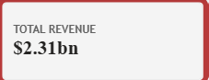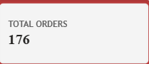
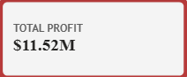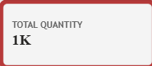
The tooltip page adds a second set of four cards: Total Revenue, Total Profit, Total Orders and Average Order Value (₹313,801.38).
The overall profit margin works out to 20.82% (₹979.89M profit on ₹4,707.02M revenue).

8. Summary Table

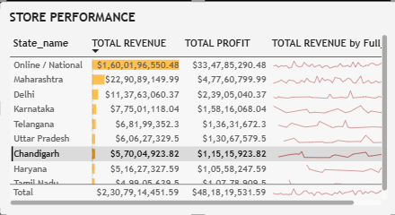A) By product category
Category | Revenue | Share of revenue | Profit | Margin | Units sold
Mobile Phones | 1,769.42 | 37.59% | 349.27 | 19.74% | 39,769
Laptops | 1,457.70 | 30.97% | 335.22 | 23.00% | 19,414
Televisions | 931.95 | 19.80% | 170.53 | 18.30% | 16,691
Home Appliances | 309.94 | 6.58% | 66.19 | 21.36% | 10,346
Audio | 157.93 | 3.36% | 41.46 | 26.25% | 13,400
Wearables | 77.56 | 1.65% | 16.30 | 21.01% | 8,694
Accessories | 2.52 | 0.05% | 0.93 | 36.69% | 4,039
Total | 4,707.02 | 100% | 979.89 | 20.82% | 112,353

B) By store type
Store type | Revenue | Share | Profit | Margin
Online | 3,248.57 | 69.02% | 676.35 | 20.82%
Urban (including the mis-cased "urban" store) | 752.23 | 15.98% | 156.66 | 20.83%
Flagship | 375.01 | 7.97% | 77.73 | 20.73%
Mall | 216.12 | 4.59% | 45.31 | 20.97%
Suburban | 115.09 | 2.45% | 23.84 | 20.71%

C) By city (physical stores)
City | Revenue | Share of total | Profit
Mumbai | 256.16 | 5.44% | 53.52
New Delhi | 242.86 | 5.16% | 50.69
Pune | 235.19 | 5.00% | 49.26
Bengaluru | 135.54 | 2.88% | 27.80
Noida | 125.28 | 2.66% | 26.17
Hyderabad | 124.94 | 2.65% | 25.43
Chandigarh | 115.14 | 2.45% | 23.72
Gurgaon | 115.09 | 2.45% | 23.84
Chennai | 108.25 | 2.30% | 23.11

D) By year
Year | Revenue | Profit | Orders | Units | Average order value
2024 | 2,346.63 | 486.50 | 7,350 | 55,104 | ₹319,269
2025 | 2,307.91 | 481.82 | 7,473 | 55,887 | ₹308,834
2026 (January only) | 52.47 | 11.57 | 177 | 1,362 | ₹296,445

E) By customer segment
Segment | Revenue | Share
Regular | 1,895.04 | 40.26%
Occasional | 1,387.68 | 29.48%
Value | 710.80 | 15.10%
Premium | 708.82 | 15.06%
" PREMIUM" (data entry variant) | 4.68 | 0.10%

9. Dashboard Visuals
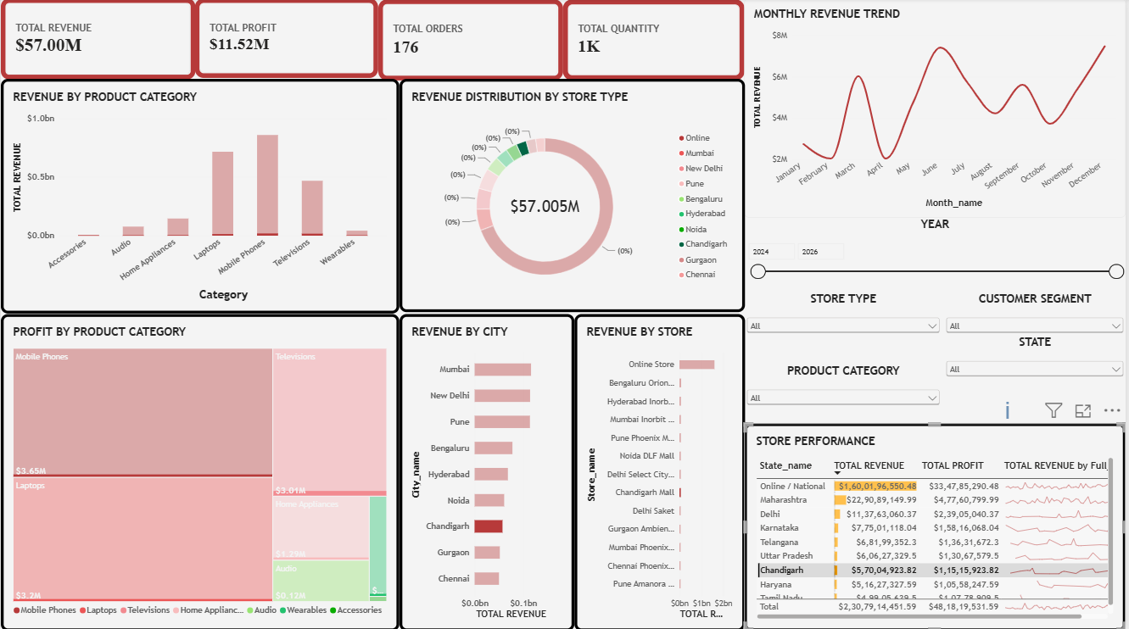
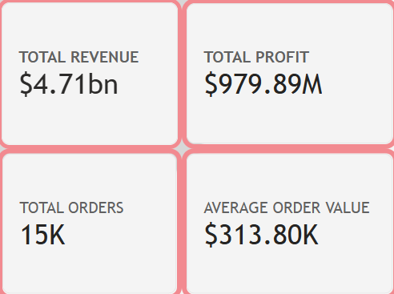
- Top row (left to right): four KPI cards for Total Revenue, Total Profit, Total Orders and Total Quantity.
- Left column: Revenue by Product Category (column chart) above Profit by Product Category (treemap).
- Centre: Revenue Distribution donut chart above two ranking bar charts, Revenue by City and Revenue by Store.
- Right column: Monthly Revenue Trend (line chart) at the top, followed by the Year range slicer, the Store Type, Customer Segment, Product Category and State dropdown slicers, and the Store Performance table at the bottom.
Visual-by-visual reading guide
- Revenue by Product Category (column chart): Mobile Phones and Laptops are the two tallest columns. Drilling down shows that premium tiers lead within each category.
- Profit by Product Category (treemap): Mobile Phones and Laptops take up almost the same area, which shows how much profit Laptops earn relative to their lower revenue.
- Revenue Distribution donut: Dominated by the Online slice. Hovering shows the tooltip page with revenue, profit, orders and average order value for that slice.
- Revenue by City (bar chart): Online is excluded by a visual filter, so the chart compares only physical-store cities. Mumbai, New Delhi and Pune lead.
- Revenue by Store (bar chart): The Online Store is far above every physical store.
- Monthly Revenue Trend (line chart): Filtered to 2025 in the saved file. Revenue climbs from February to a peak in October.
- Store Performance (table): Lists each state by revenue and profit with orange data bars and a small revenue sparkline. Sorted by revenue, highest first.
Design notes and suggested fixes
- The donut chart is titled "Revenue Distribution by Store Type" but is built on City_name, not Store_type. Either the title or the field should be changed so they match.
- The tooltip page is named "STORE TYPE TOOLTIP", which supports the idea that the donut was meant to show store type.
- The line chart's year filter was created by drilling, so the trend shows only 2025 unless the filter is cleared. A title note would help readers.

10. Key Findings
- Overall performance. The business earned ₹4,707.02M in revenue and ₹979.89M in profit from 15,000 orders and 112,353 units, a profit margin of 20.82%. Average order value is ₹313,801.
- Online dominates. The Online Store generates ₹3,248.57M, or 69.02% of all revenue. That is about 2.2 times the revenue of all 12 physical stores combined (₹1,458.45M) and about 23 times the best physical store (Mumbai Inorbit Mall, ₹139.69M).
- Two categories drive the business. Mobile Phones (37.59%) and Laptops (30.97%) together contribute 68.56% of revenue. Adding Televisions brings the top three to 88.36%.
- Laptops are the profit-efficient category. Laptops earn almost the same profit as Mobile Phones (₹335.22M vs ₹349.27M) from about 82% of the revenue, because their margin is 23.00% against 19.74%.
- Margins differ widely by category. Accessories (36.69%) and Audio (26.25%) have the best margins but very small revenue. Televisions have the lowest margin at 18.30%.
- Premium products lead. Premium Smartphones (₹894.05M, 18.99% of revenue) and Premium Laptops (₹603.64M) are the top two subcategories.
- Brand concentration. Samsung (22.24%) and Apple (19.25%) together account for about 41.5% of revenue. Dell, HP and ASUS earn higher margins (about 23.5%) than Apple (19.94%), Sony (18.71%) or LG (18.94%).
- City ranking. Among physical-store cities, Mumbai (₹256.16M), New Delhi (₹242.86M) and Pune (₹235.19M) lead. Chennai (₹108.25M) is lowest. Maharashtra, with Mumbai and Pune, is the strongest state at ₹491.35M.
- Store-type margins are almost identical. All store types earn between 20.7% and 21.0%, so the difference between channels is in volume, not in profitability.
- Flat year-on-year performance. 2025 revenue (₹2,307.91M) was about 1.7% lower than 2024 (₹2,346.63M), even though orders rose about 1.7% (7,350 to 7,473). Average order value therefore fell by roughly 3.3%.
- Clear seasonality. Revenue peaks every year in October (₹256.36M in 2024, ₹228.40M in 2025), with a second strong period in July–August.
- Festive-season margin squeeze. Profit margin drops to about 18.7–19.2% from October to December, compared with roughly 21–22% in other months. This suggests heavier discounting during the festive season, although the data alone cannot confirm the cause.
- Customer base. Regular customers bring 40.26% of revenue and Occasional customers 29.48%. Premium and Value segments contribute almost the same amount (about 15% each).
- Returns are low. About 1.95% of sale lines (292 of 15,000) were returned.

11. Conclusion
The Retail Sales Dashboard turns nine raw CSV files into a single interactive view of sales, profit and customer behaviour. The star-schema model, the eight DAX measures and the combination of KPI cards, charts, slicers and a tooltip page let a user move from headline numbers to category, city, store and monthly detail in a few clicks.
The analysis shows a business that is healthy in margin (about 21%) but heavily dependent on two things: the online channel (69% of revenue) and two product categories (Mobile Phones and Laptops, about 69%). Revenue was flat from 2024 to 2025 and average order value slipped, while October to December margins weaken.
Recommendations
- Protect and grow the online channel, and look for ways to lift physical-store sales, especially in lower-ranked cities such as Chennai and Gurgaon.
- Promote high-margin lines such as Laptops, Audio and Accessories, and review discount levels in the festive quarter.
- Fix the data-quality issues listed in Section 4.2, correct the donut chart's field or title, and add a profit margin measure and year-over-year comparisons to the dashboard.
- Consider separating tax from revenue so that profit is reported on a tax-exclusive basis.

12. References
Microsoft Power bi project

